Sketch Basic Eye Shape
- First, sketch a really simple shape, it looks like a tree leaf, with one end having a little nodule and the other end being sharp.
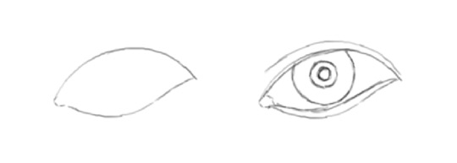
- In step 2, start to draw the eye's creases with a line above upper eyelid and one below lower eyelid. Note the difference between the two crease-lines.
- To draw the iris, very lightly sketch three circles: the biggest one is the outline of iris; next one is for the dark area around eye pupil; and lastly, the smallest circle is for eye pupil itself.
Eyes Details And Shading
- Fill the pupil circle with solid black color - make it the darkest black you can. Then put in some stroke lines expanding between the pupil and iris.
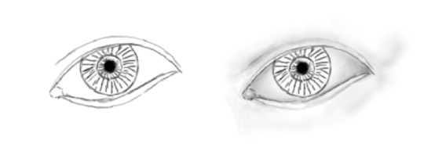
- After you finish drawing eyes outlines, it's time to start shading to give it depth and spherical feel. The eyeball is darker closer to the eye-lids.
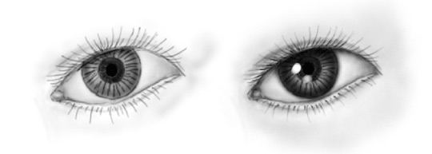
- Start to draw eyelashes. Note how eyelashes on the top eye-lid are longer and more dense than eyelashes on the bottom eyelid. Give the eye a 3D feel by rubbing a circle or square to create a white shape that represents the reflected light.
