Make a bird feeder/Bird house

You will need:
One clean milk carton
Long piece of string or ribbon
Scissors
Permanent marker pens e.g. Sharpie pens
Bird seed or some soft bedding.

Instructions:
- Wash out the milk carton and allow to dry.
- Adult help may be needed - use the scissors to cut an entrance on the side of the carton for the bird to get into the feeder/house. You may leave the door attached or cut it off and you could have another opening on the other side too.
- Decorate your carton however you wish.
- You may need another pair of hands here! -Take the lid off the carton and place the long piece of string/ribbon across the open top. Screw the lid back on securing the string in place. Tie the two ends together to create a handle for the bird house/feeder.
- Put the bird seed or bedding inside the bottle.
- All done! You just need to decide where to hang your bird feeder/house now.

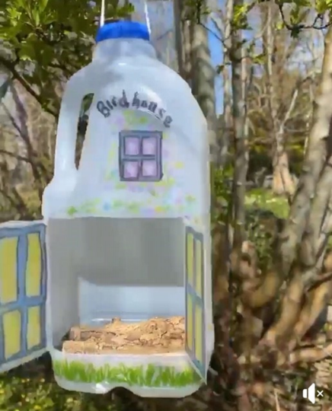
Extra details –
- Glue twigs to the top of the carton to create a roof.
- Add some twig branches for the bird to perch on. Push through a twig from one side to the other so it is secure.

