How do our lungs work?
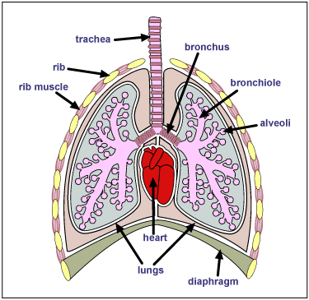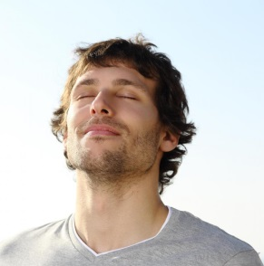
Breathing in
- When you inhale, or breathe in, the oxygen goes in through your nose or mouth. Little hairs called cilia (say silly-a) inside your nostrils catch tiny particles of dust. If they don't catch all of them, there are more cilia and mucus inside your trachea, which trap the dust and stop it from getting into your lungs. Your diaphragm flattens out (contracts), your ribcage lifts to allow oxygen into the lungs.

- Oxygen comes down the trachea (say trak-ee-a), or windpipe, into two large tubes called the bronchi (say bron-key). One bronchus (say bron-kuss) goes into the left lung and the other into the right.

- Each bronchus is rather like the trunk of a tree because it has what look like branches and twigs growing from it. The smallest 'twigs' are called bronchioles (say bron-key-oles). They are so tiny that they are like hairs.

- At the end of these bronchioles there are little bunches of alveoli (say al-vee-o-lie). These are sacs, or little bags, full of oxygen. There are about 600 million of them in your lungs, so you can imagine how tiny they are.

- Each tiny alveolus (that's the name for one of them) is covered in even tinier blood vessels called capillaries . Oxygen goes through the walls of the alveoli and into the capillaries where the oxygen enters the red blood cells in each tiny blood vessel. The blood carries the oxygen to the left side of the heart. The heart pumps all the oxygen-carrying blood to every cell in the body.

Breathing out

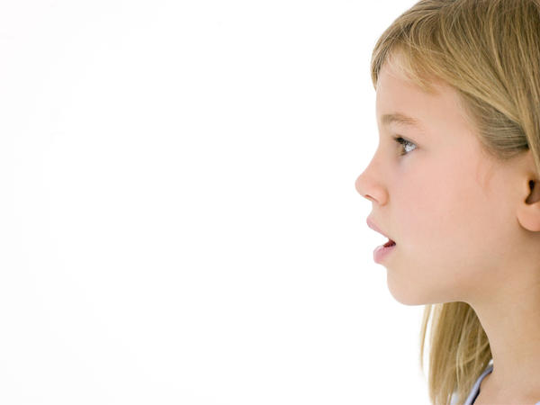
- As each red blood cell empties its load of oxygen, it picks up carbon dioxide from the cells and heads back in the veins to the right side of the heart which then pumps the deoxygenated blood to both lungs.

- The carbon dioxide is carried by the red blood cells to the lungs' capillaries surrounding the alveoli, then through the bronchioles, up through each bronchus, out up into the trachea and finally the carbon dioxide leaves the body through the nose or mouth when you breathe out.

- For you to exhale, or breathe out, the diaphragm relaxes, muscles between the ribs relax and carbon dioxide is pushed out of the lungs.

