Anglo Saxon Place Names

Can you use the separate vocabulary list to help you work out the meanings of these place names? The Place Names and Meanings are all jumbled up at the moment!
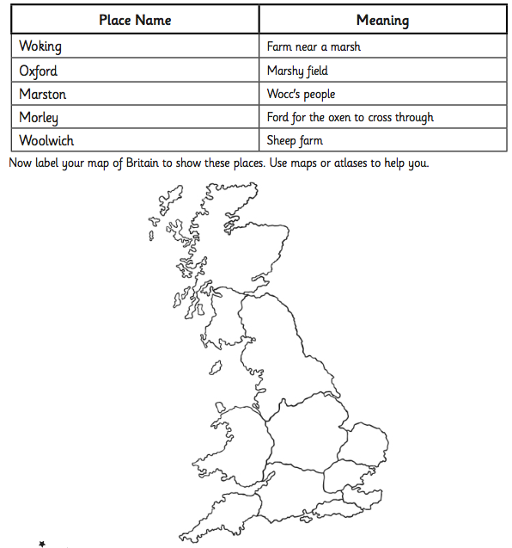

Anglo Saxon Place Names

Can you use the separate vocabulary list to help you work out the meanings of these place names? The Place Names and Meanings are all jumbled up at the moment!
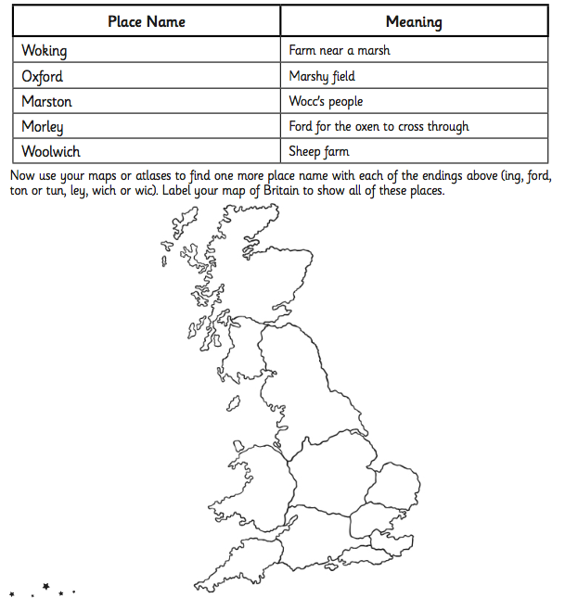

Anglo Saxon Place Names

Can you use the separate vocabulary list to help you work out the meanings of these place names? The Place Names and Meanings are all jumbled up at the moment!
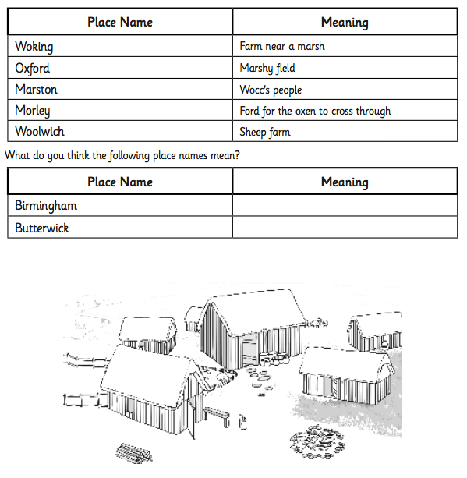
Colour this in if you would like to!

