History Lesson 3:
LO To find out what archaeologists do and why they dig for evidence.

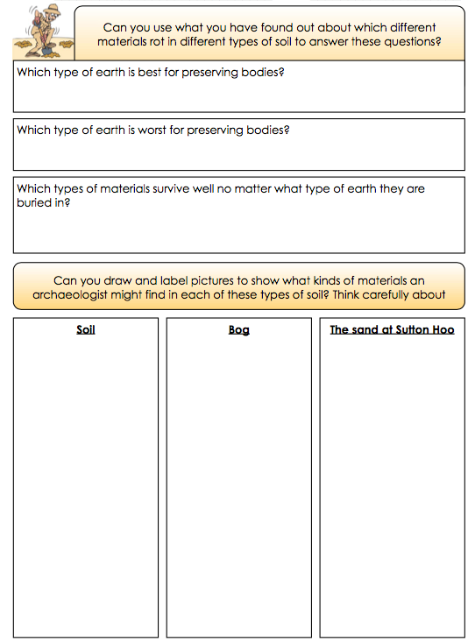
Complete this sheet using the information you found out in your research about different types of soil.

