**Label the heart using the names below:**

Left Atrium

Right Atrium

Left Ventricle

Right Ventricle

Septum

Superior vena cava

Inferior vena cava

Pulmonary artery

Pulmonary vein

Aorta branches

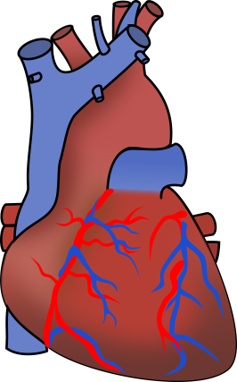

3. The right ventricle fills and contracts to pump blood to the lungs. The right ventricle pumps blood through the pulmonary valve into the pulmonary artery. Once blood passes into the pulmonary artery the pulmonary valve closes to prevent backflow of blood into the right ventricle.

**HEART ALERT!!**

The heart is seen from the front in the diagram. So the **right** side of the heart is shown on the **left** of the diagram. The **left** side is on the **right** side of the diagram.

**Task**

Activity 1 – Use the statements labelled 1 to 8 to help you label your diagram. The parts of the heart are listed in green.

Activity 2 –Then, using your own words, explain in sentences around the heart diagram how the heart works (use the statements in activity 1 as a guide).

Challenge tasks – Using the additional support sheet, create some extra notes about the heart e.g. the heart is a muscle that acts like a pump.

Finally can you label the name of each of the valves within the heart?

8. The aorta branches into arteries that deliver blood throughout the body.

7. The left ventricle, the most muscular chamber of the heart, then contracts with enough pressure to send the blood through the aortic valve and into the aorta. After the blood passes through the aortic valve it closes to prevent backflow of blood into the left ventricle.

1. The two largest veins in the body, the superior and inferior vena cava, bring the de-oxygenated (highlighted in blue) blood to the heart into the right atrium.

2. De-oxygenated blood passes through the tricuspid valve into the right ventricle. The tricuspid valve closes after the blood passes through to prevent it from flowing back into the right atrium.

6. The oxygenated blood then flows through the mitral valve and into the left ventricle. The mitral valve closes after the blood passes through to prevent backflow.

5. Oxygenated blood (highlighted in red) leaving the lungs enters the heart through the pulmonary veins and is carried into the left atrium.

4. The two branches of the pulmonary artery carry blood to both lungs. In the lungs, the blood picks up oxygen and expels carbon dioxide.