Wednesday 10th June
LO: To order numbers to 100
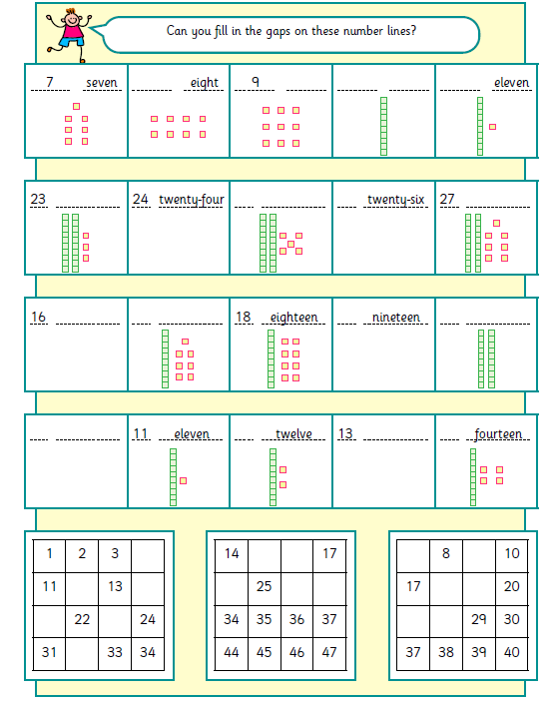
e)
d)
c)
b)
a)
Twenty ten sixteen seventeen twenty-seven
Twenty-three thirteen nine twenty-five ten

