Price List

Loaf of Bread 12p

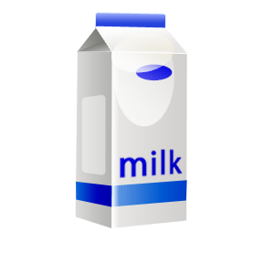

Milk 20p

MCj02159370000[1]

Bar of chocolate 15p

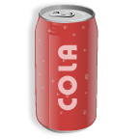

6 cans of Coke 20p

MCj04078260000[1]Bag of potatoes 23p

**L.O To be able to find the totals of 2/3 items, using my number bonds and counting on.**

**S.C 1. 2. 3. 4. 5.**

Work out the answers to the following problems using your price list.

MCj02159370000[1]

MCj04078260000[1]



MCj02159370000[1]

MCj04078260000[1]

MCj02159370000[1]MCj04078260000[1]