Find half of each number by sharing the blue dots equally between Batman and Robin?

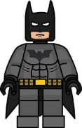
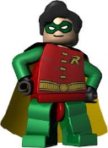
½ of 4=
½ of 6=
½ of 2=
½ of 8=
½ of 14=
½ of 12=
½ of 10=

