Find half of each number by sharing the blue dots equally between Batman and Robin?
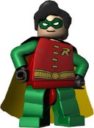
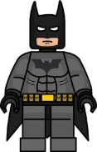
½ of 2=

½ of 4=

½ of 6=

½ of 8=

½ of 10=

