- Circle the adjectives that appropriately describe Goldilocks.

curly hair cheeky
disrespectful
young impolite
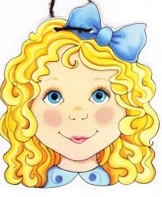
old blonde

kind charming

thoughtful rude

- Can you use the adjectives you have circled to write a character description of Goldilocks?
Things to think about:
What does she look like?
What is her character like? How do you know? What does she do in the story that shows this?
Use conjunctions to explain your ideas further:
when because and if since
E.g. Goldilocks was extremely rude when she walked in to the bear’s house. She is very impolite because she ate all of the bear’s porridge and sat in all their chairs.

