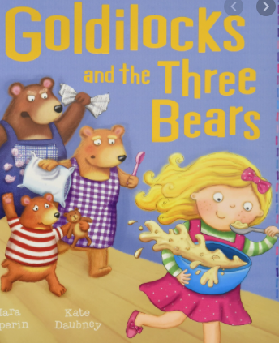
A subordinating conjunction is a word that joins two clauses together.
Use the subordinating conjunctions, when, if, that, because to join the clauses together.

- Goldilocks ate all of baby bear’s porridge she was so hungry.

- Daddy Bear was very angry _______ he realised somebody had broken in.

- She was so tired _____ she fell asleep instantly.

- Goldilocks’ Mother scolded her and told her that ____ she ever ran away again she would be in big trouble.
Try using ‘when’, ‘if’, or ‘since’ at the start of these sentences to add more detail.
e.g Since there was no answer, Goldilocks decided to walk inside.

- ____________________________, she saw 3 angry bears staring at her.

- ___________________________, she would never be allowed out again.

- ____________________________, she has never set foot in the woods again.

