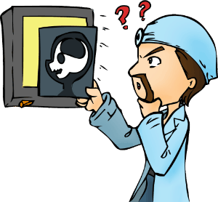
Title
Nouns
Indefinite article
Rhyming words
Opening sentences
Closing sentences
That Explains It!
I went to the doctor. He x-rayed my head.
He stared for a moment and here’s what he said.
“It looks like you’ve got a banana in there,
an apple, an orange, a peach, and a pear.
I also see something that looks like a shoe,
a plate of spaghetti, some fake doggy doo,
an airplane, an arrow, a barrel, a chair,
a salmon, a camera, some old underwear,
a penny, a pickle, a pencil, a pen,
a hairy canary, a hammer, a hen,
a whistle, a thistle, a missile, a duck,
an icicle, bicycle, tricycle, truck.
With all of the junk that you have in your head
it’s kind of amazing you got out of bed.
The good news, at least, is you shouldn’t feel pain.
From what I can see here you don’t have a brain.”

What is this poem about?

