Use the key below to shade in the features of this shape poem. Answer the questions below.
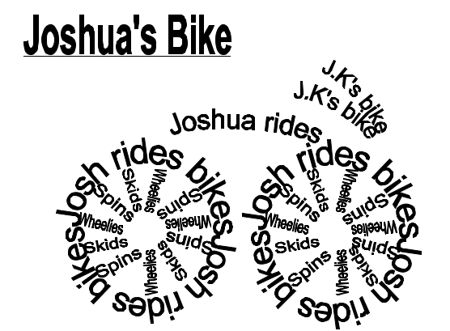

Title
Nouns
Adjectives
Repetition

Does this poem use words, phrases or both?

What shape is this poem?

What is this poem about?

