Wednesday, 6th January, 2021

L.O To listen to/read a story and respond, explaining what I know about the main character.

S.C 1. 2. 3. 4.

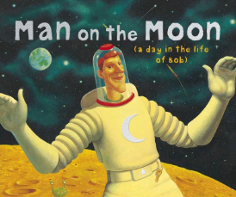
Write in full sentences (C.L, F.S, Punc, Conj)
Think about - Appearance (What he looks like), Personality (how he behaves), actions (what he does) and any other information…

