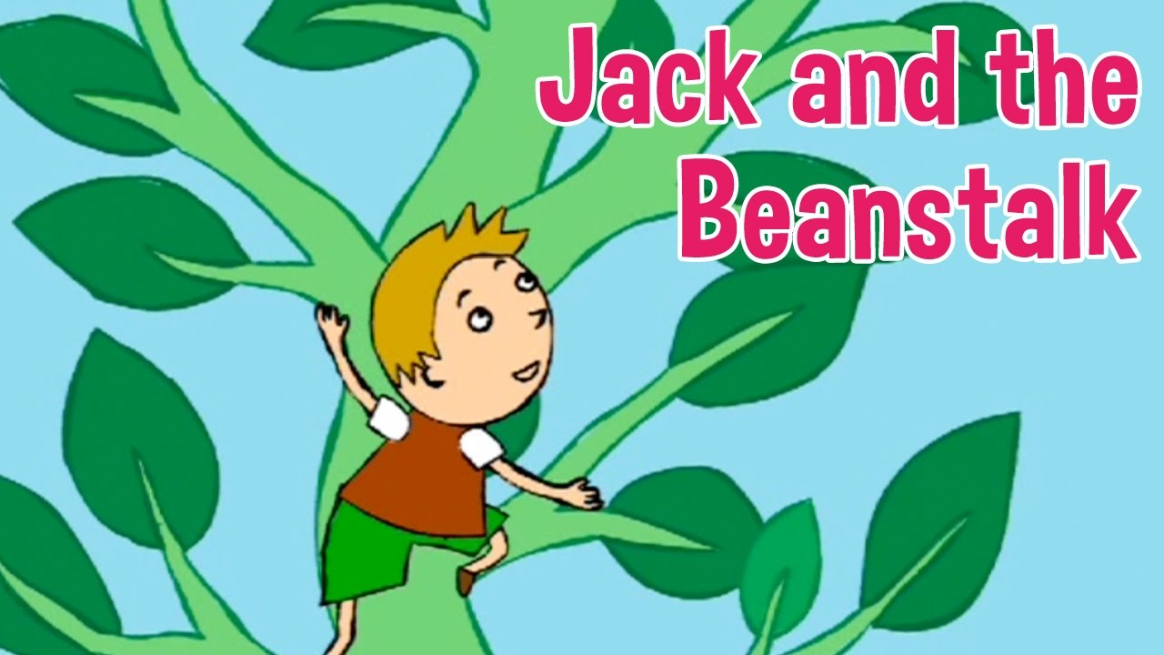
Giraffe Group | Elephant and Lion Group | Cheetahs and Meerkat
Remember a letter is not like a story. They do not start with once upon a time, they start with ‘dear’ When you are writing your letter, I want you to think about how you might be feeling. Write some simple sentences that start with I feel…… then think of some words that you can add at the end. Try and use your phonics to write these words independently.  Remember full stops, finger spaces and capital letters. Try and keep your letters on the line. | Remember a letter is not like a story. They do not start with once upon a time, they start with ‘dear’ When you are writing your letter, I want you to think about how you might be feeling. Write some simple sentences that start with I feel…… then think of some words that you can add at the end. Try and use your phonics to write these words independently. Can you challenge yourself to describe the giant too using 2 simple sentences?  Remember full stops, finger spaces and capital letters. Try and keep your letters on the line. | Remember a letter is not like a story. They do not start with once upon a time, they start with ‘dear’ When you are writing your letter, I want you to think about how you might be feeling? What does the castle look like? What are the giant and his wife like? What different treasures can you see in the castle? What was it like climbing the beanstalk? Remember to use capital letters and full stops.Can you challenge yourself to use adjectives too?

Extra lines if needed or narrow lines if preferred:

