Lesson 4
LO: to describe a mythical creature (planning)
SPAG LO (embedded): using expanded noun phrases.
Please use the story of Romulus and Remus as the basis of this lesson.
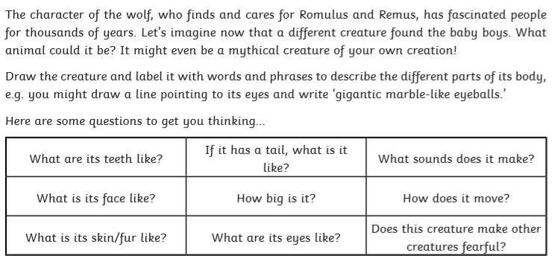

Please draw a picture of your mythical creature and then write a short description of it. In your description please use all our learning this week
I’m looking for:
Beautiful handwriting
Finger spaces
Full stops and capital letters
Expanded noun phrases (description)
Challenge -
If you can, try a range of punctuation too ! , ?
Super Challenge - add some WOW words

