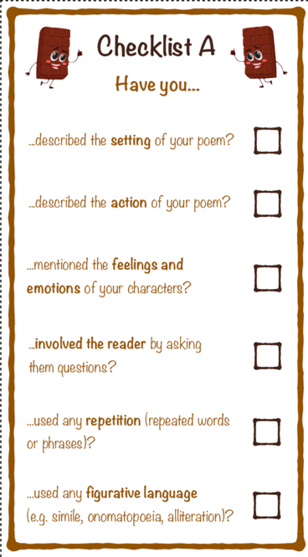
LO: To write a chocolate-themed poem ENGLISH Lesson 4

