**Chapter 5 – The Glass Eye (Pages 9 - 11)**

2a – give/explain the meaning of words in context

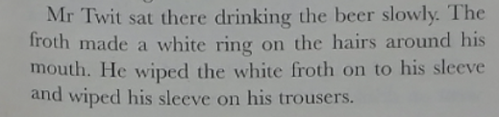

1. What is ‘froth’? Draw a picture of Mr Twit’s beard after drinking his beer to explain your answer.

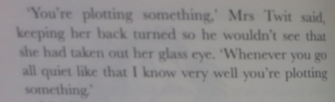

1. What does it mean to plot something?

**Chapter 6 – The Frog (Pages 12 - 15)**

2a – give/explain the meaning of words in context

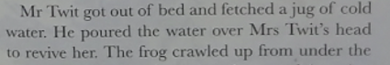

1. What does the word ‘revive’ mean?

2d – make inferences from the text/explain and justify inferences with evidence from the text.

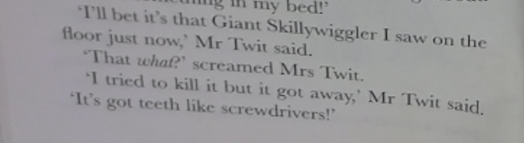

1. Why does Mr Twit say ‘it’s a Giant Skillywiggler’?
2. Why did Mrs Twit sleep on the sofa?