**Chapter 5 – The Glass Eye (Pages 9 - 11)**

2a – give/explain the meaning of words in context

1. What is ‘froth’? Draw a picture of Mr Twit’s beard after drinking his beer to explain your answer.
2. What does it mean to plot something?

2d – make inferences from the text/explain and justify inferences with evidence from the text.

1. How did Mrs Twit know Mr Twit was plotting something?

2f – identify/explain how narrative content is related and contributes to meaning as a whole.

1. Do you think the Twits like each other? Why?

**Chapter 6 – The Frog (Pages 12 - 15)**

2c – summarise main ideas from more than one paragraph

2h – make comparisons within the text

1. Summarise each trick in one sentence. Are the tricks similar?

2a – give/explain the meaning of words in context

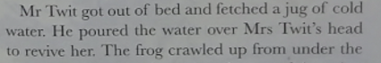

1. What does the word ‘revive’ mean?

2d – make inferences from the text/explain and justify inferences with evidence from the text.

1. How did Mrs Twit know the frog was there?
2. Why does Mr Twit say ‘it’s a Giant Skillywiggler’?
3. Why did Mrs Twit sleep on the sofa?