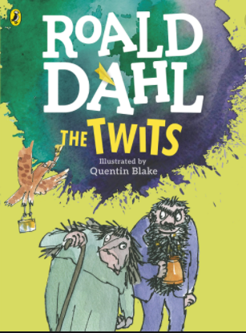

- What do you think the book will be about?

- What can you see on the front cover?

- What sort of story do you think it will be? (E.g adventure, funny, scary, sad, fantasy)

- Who might enjoy this story?

- Do you think you will enjoy reading this book? Can you explain why or why not?

