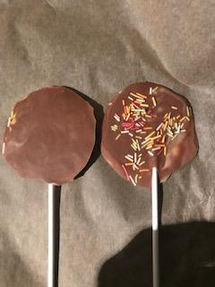
LOLLY 1: This lolly was made using the method we decided on previously
Appealing shape?
Thickness of chocolate?
Decorations?
Tasty? | I’ve done this for you! Very tasty 😊
Does it look professional?
Can it be improved?
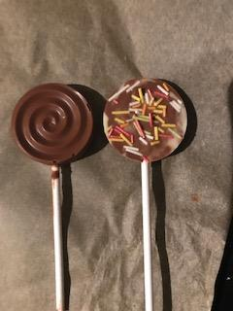
LOLLY 2: This lolly was made using a different method to the one we decided on previously
Appealing shape?
Thickness of chocolate?
Decorations?
Tasty? | Extremely tasty 😊😊
Does it look professional?
Can it be improved?

