**Draw a picture of yourself**

You must have:

2 eyes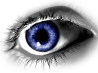 2 eyebrows

2 ears C:\Users\Hare\AppData\Local\Microsoft\Windows\Temporary Internet Files\Content.IE5\196XX59T\MC900238192[1].wmf 2 legs 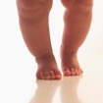

2 nostrils C:\Users\Hare\AppData\Local\Microsoft\Windows\Temporary Internet Files\Content.IE5\I66XJ6D7\MC900028142[1].wmf 2 arms C:\Users\Hare\AppData\Local\Microsoft\Windows\Temporary Internet Files\Content.IE5\I66XJ6D7\MC900339768[1].wmf

5 fingers on each hand and 5 toes on each foot.

What is the total amount of all your body parts?