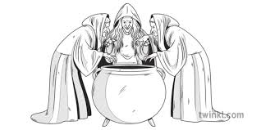
Describing and creating the witches

Banquo’s description of the witches:
“What are these
So withered and so wild in their attire
That look not like the inhabitants of the earth
And yet are on it? Live you? Or are you aught
That man may question? You seem to understand me
By each at once her choppy finger laying
Upon her skinny lips. You should be women
And yet your beards forbid me to interpret
That you are so…”
- What do you learn about the witches from this speech?
- Can you draw what you think the witches look like, based on Banquo’s speech above?

In Shakespeare’s time, people believed that witches were real:
- Use the Internet to find out about what people believed about witches in the 16th/17th centuries.

