How to Make Gears
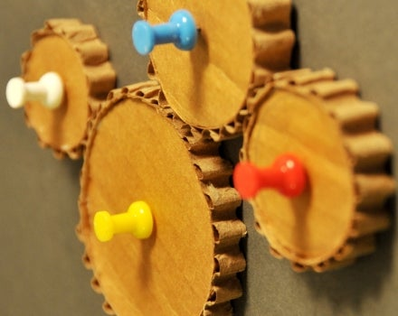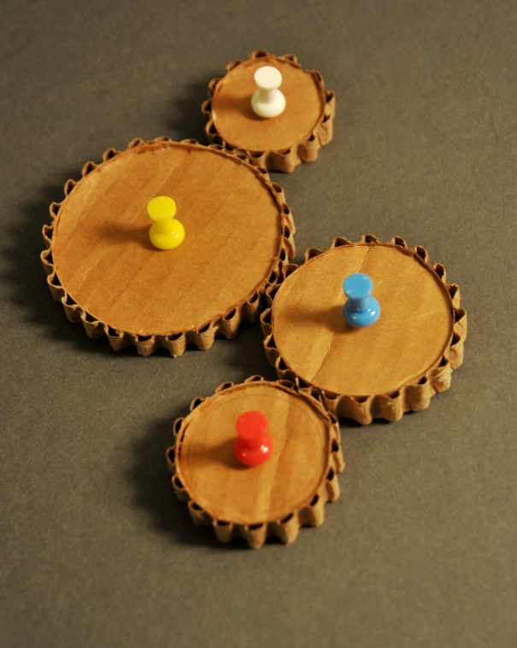

L.O. To be able to make gears and to understand how they rotate when they mesh together.
Lesson 1
In this lesson you are going to revise your knowledge of gears and then have a go at making some.
Revision of gears
Gears are the toothed wheels used in many machines, including bicycles, where they work together to change the relationship between the driving mechanism and the moving parts. You pedal the cranks (a devise that moves things in a circle, with a lever attached at right angles) to turn the chain-ring, which is connected by a chain to smaller gears that move the rear wheel. You change gears depending on the landscape you are travelling over. If you are riding up a steep hill, you might want to change into a lower (larger) gear. This makes it easier to turn the cranks, but the rear wheel doesn’t turn as much with each rotation of the cranks. When you get to a level or downhill stretch of road, you probably switch to a higher gear (smaller), where each turn of the cranks leads to more turns of the rear wheel.
Look around your home and find some mechanisms that use gears. List some examples.

The maths part!
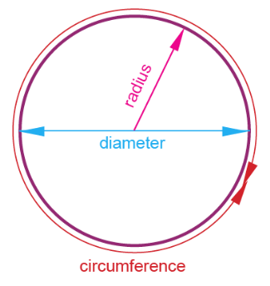
The radius of a circle is the distance from its centre to its edge. Diameter is twice the radius—it’s the straight line distance across the centre of a circle to the outer edges. Circumference is the distance around a circle. Thousands of years ago, Greek mathematicians discovered the ratio of a circle’s circumference to its diameter and called it π (pi), which is approximately equal to 3.14. The circumference of a circle can be found using the following equation: πd=C. As a challenge you can use this equation to help you cut out your cardboard gear teeth later on. E.g. if you have a diameter of 10cm, multiply 3.14 (π (pi) x 10 = 31.4cm circumference

Materials you will need to make your gears
- Cardboard box made of corrugated cardboard. Corrugated cardboard has the ridges inside.
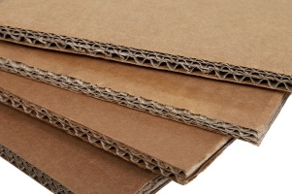
- Ruler
- Pencil
- Compass (the kind you draw circles with) or different sized lids to draw around
- Sharp scissors
- Glue
- Permanent Marker

Procedure

(If you can, please take pictures of the different stages of the making process and your finished mechanism.)
- Cut out a piece of cardboard that is at least 25cm x 25 cm. This will be your base.
- On another piece of cardboard, use the compass to trace out at least four circles with approximately 2cm, 4cm, 6cm, and 8cm diameters. Remember that a radius is half the diameter, so if you set the compass radius at 1cm, 2cm, 3cm and 4cm, to achieve the correct circle diameters. If you are drawing around different sized lids make sure they vary in size.
- Cut out the circles that you have drawn. The rounder your circles are, the better they will work.
- Two options for calculating the size of the circumference. Option 1: Use a piece of string to measure around the outer edge of the circle, mark the distance on the string and then lay it out flat along the ruler to measure the circumference in cm.
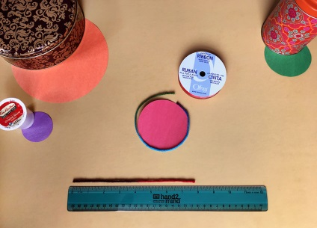
Option 2 the challenge: Figure out the circumference of each of your circles by multiplying the diameter by π (e.g. 3.14 x 2cm = 6.28 cm circumference)
- Next, you are going to give each of your gears toothed edges. Making sure to cut along the corrugates, cut a long strip of cardboard 1 cm wide (you will need to judge this depending on the depth of each cardboard circle that you have cut out).
- Jam your fingernail into the corrugate and carefully remove the brown paper on one side of the corrugated cardboard. You should be left with lots of bumps, without any paper still stuck on. This can be tricky, so be patient!
- Using the circumferences that you have calculated, cut out a piece of stripped corrugated cardboard for each of your circles.
- Cover your work area with newspapers and then spread glue around the edge of your first circle.
- Roll the correctly measured piece of corrugated cardboard around the circle, making sure the bumps are on the outside.
- Secure the stripped corrugated cardboard with a push pin or masking tape until it is dry and then remove.
- Repeat for each of your other circles.
- Use a black permanent marker to make a black mark at one tooth of each of your gears. This way you will able to track when each has made a rotation.
- Attach the gears to your 25x25cm board, using pushpins at the centre of each and making sure that the gears’ teeth mesh (interlock together).
- Rotate the largest gear clockwise. Which way does the smallest gear turn? Note down which gears turn clockwise and which gears turn anticlockwise.
- Using the black marks to keep track, turn the 4cm circle once. How many times does the 2cm gear turn?
- Now, turn the 8cm gear once. How many times does the 4cm gear turn?
- Turn the gears in different orders what do you notice?
- Don’t forget to take a photo of your finished mechanism.
As designers you will be creating changes and making improvements so don’t worry if you have to use different materials to the ones listed above or if your model is not exactly the same as the photo. Good luck!

Lesson 2
L.O. To be able to record my observations of rotating gears.
In this lesson you are going to present your findings in a poster or information sheet. You can produce your work on a computer or in a hand written/drawn format. Include the photographs that you took in the design and make lesson. If you were unable to take photographs, I would like detailed diagrams of your finished product including arrows to show the direction of rotation (remember to label the driver gear). Record the number of rotations that your gears made, for example when you turned the driver gear that was 8cm in diameter, how many rotations did the gear make that was 2cm in diameter? When you turned the driver gear that had a diameter of 4cm clockwise, which direction did the other gears turn?
Include a description of what a gear is and any examples of mechanisms that use gears around the home.
Extension: Explore making other gears of different sizes and orientations. Then record your findings.

