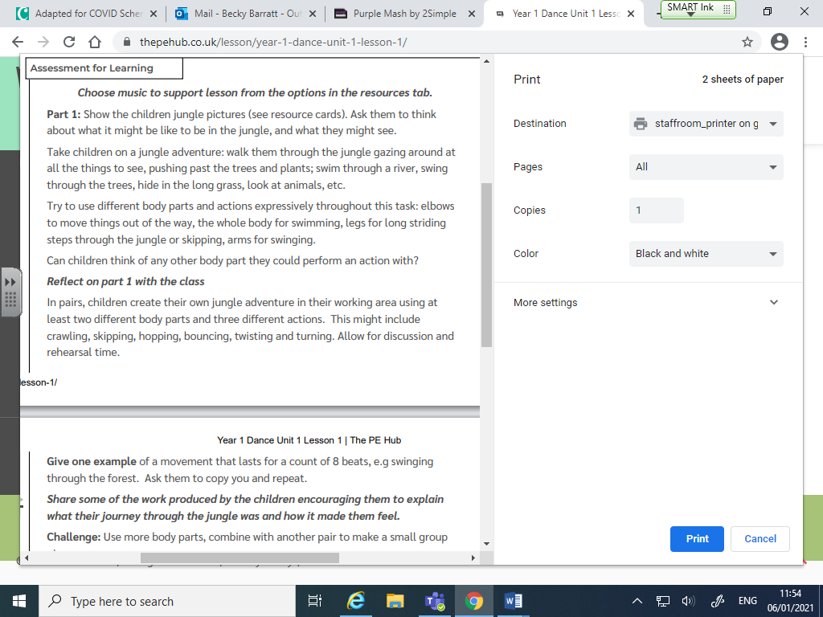

**Resource Cards**

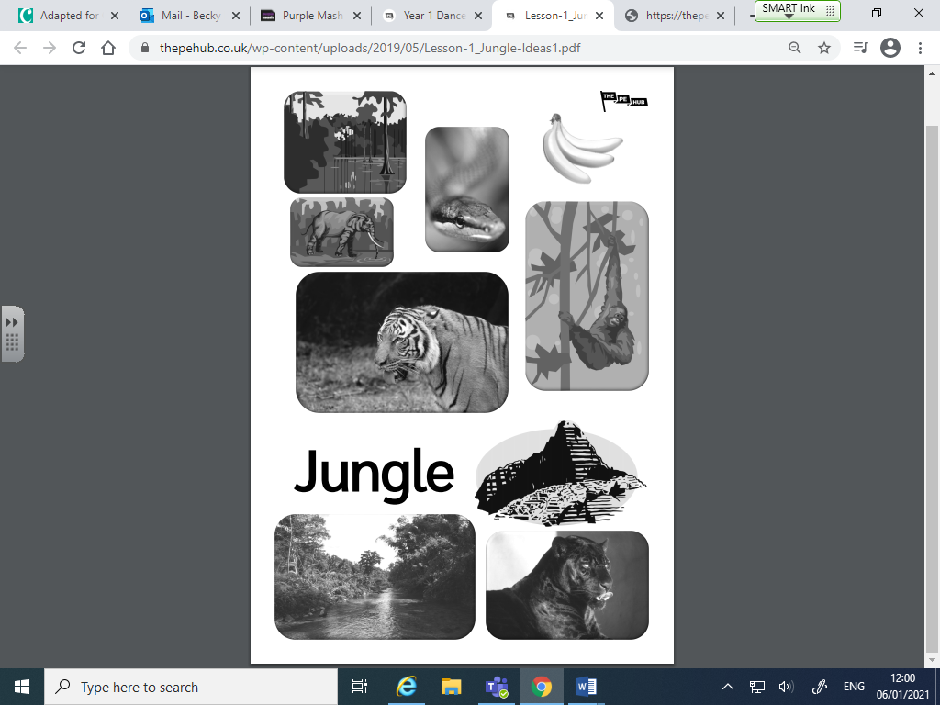

<https://www.youtube.com/watch?v=pVwvSP2KyrU&feature=youtu.be>