 | Objective: | To understand finding the area of shapes.
 | Milestone 2 | Can I understand that area is how much space is taken up by a 2D shape or surface?
Challenge 1
Varied Fluency

1. How many post-it notes did you use to cover your piece of paper?

2. Draw the shapes you created using your squares of paper neatly on the lines of your book.
3. What is the same and what is different about these shapes? Which of the shapes has the largest area?

Challenge 1
Varied Fluency

1. How many post-it notes did you use to cover your piece of paper?

2. Draw the shapes you created using your squares of paper neatly on the lines of your book.
3. What is the same and what is different about these shapes? Which of the shapes has the largest area?

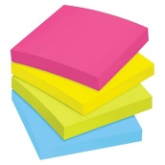

Challenge 2
Reasoning and Problem Solving

Challenge 2
Reasoning and Problem Solving

 | Objective: | To understand finding the area of shapes.
 | Milestone 2 | Can I understand that area is how much space is taken up by a 2D shape or surface?
Challenge 3
Reasoning and Problem Solving

Do you agree with Ella the Egyptian?
Explain your answer.

I can use circles to measure the area of the lid of this sarcophagus.
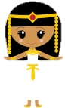

Challenge 3
Reasoning and Problem Solving

Do you agree with Ella the Egyptian?
Explain your answer.

I can use circles to measure the area of the lid of this sarcophagus.

Extra Challenge
Reasoning and Problem Solving
The area of this tile is 16 squares.
Do you agree? Why/why not?

Extra Challenge
Reasoning and Problem Solving
The area of this tile is 16 squares.
Do you agree? Why/why not?

