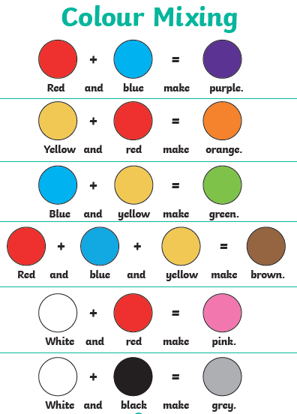

**Look at the colour mixing chart below. In the blank boxes make your own colour sums. Can you make the colour sums without looking at the chart?**