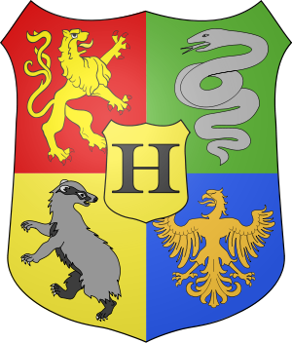
March 2020

‘Coat of arms’
I would like you to design your own coat of arms. Think about what is unique about you, and/or your family, and try to represent this. Use simple images and no more than 5 colours. Look online at some examples (like the ones above).
You need to label, or write a description, of what each element is and why you chose it. You can use the template below or create your own. Be creative.
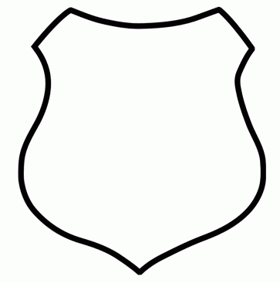
We have discussed the importance of the children really taking charge of what they do and giving it their full effort and attention. Remember, it is their work and should reflect the time and effort they have put in. That said, helping them is of course allowed.

