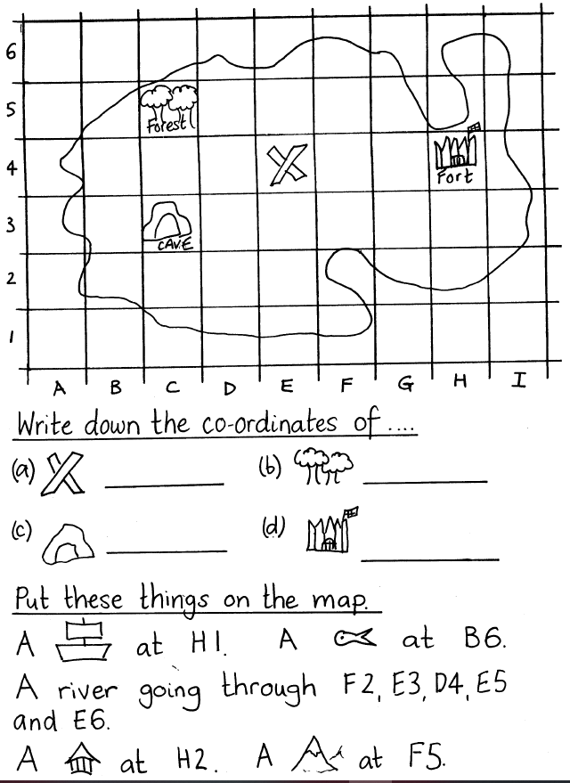
REMEMBER that when using co-ordinates, you go “into the house (along the corridor)” first – LETTERS – and then you go “up the stairs” next – NUMBERS (A3, H6 etc).

