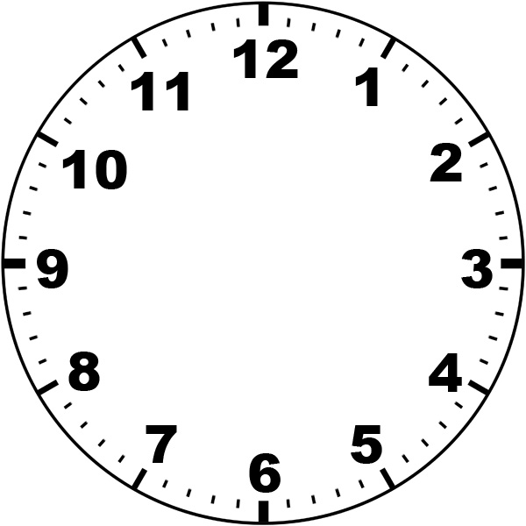

L.O To demonstrate my time knowledge
S.C 1. 2. 3.
There are __________ seconds in one minute. There are __________ minutes in one hour.
There are _________ hours in one day. There are ___________ days in one week.
Midday is at _________________ Midnight is at ________________
We say ____ for times in the morning and _____ for times in the afternoon/evening (AM or PM)
There are _______ days in January. There are _______ days in February.
There are ______ days in February in a leap year. There are _______ days in March.
There are ______ days in April. There are ______ days in May.
There are _______ days in June. There are ______ days in July
There are ______ days in August. There are ______ days in September.
There are ______ days in October. There are ______ days in November.
There are _____ days in December. There are ______ weeks in a year.
There are ______ days in a year. There are ______ days in a leap year.
There are ______ years in a decade. There are ______ years in a century.

