Circulatory System
The function of the circulatory system is to transport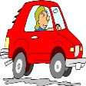 blood around the body so the three main parts of the circulatory system are: the heart, blood vessels and blood.
Blood
In the pack we gave you a couple of weeks ago, I set a task to study the components of blood (red blood cells, white blood cells, platelets and plasma) and their function. Blood serves as a transport system for oxygen, nutrients and waste materials.
Are there any parts of the human body that do not bleed when cut? Every main part of the human body requires blood, apart from hair and finger/toenails. Look at the underside of your wrists what can you find? You should be able to see your blood vessels, these are tubes that are spread throughout the body and these tubes carry and contain blood. The three main blood vessels are arteries, veins and capillaries. Did you spot some blue looking lines when you studied your wrist? These are your veins, remember your blood is always red and in your veins blood has little oxygen (deoxygenated) therefore is a darker red, it almost looks blue when covered by your skin (light interacts with the skin in different ways, so veins near the surface remits more of a blue colour).

Blood vessels (long tubes that network throughout the body).

Arteries
- Arteries carry blood away from the left side of the heart (always oxygenated apart from the pulmonary artery which goes from the heart to the lungs).
- Arteries deliver oxygen, water and nutrients all around the body.
- Have thick muscular walls.
- Have small passageways for blood.
- Contain blood under high pressure.
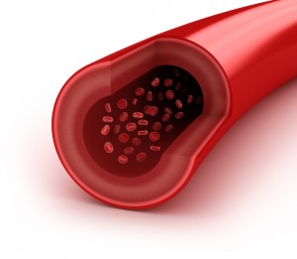

Veins
- Veins carry deoxygenated blood to the right side of the heart (always deoxygenated apart from the pulmonary vein which goes from the lungs to the heart).
- Have thin walls.
- Have larger passageways for blood.
- Contain blood under low pressure.
- Have valves to prevent blood flowing backwards.
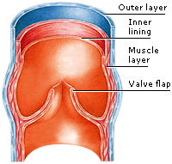

Capillaries
- Tiny capillaries connect arteries and veins.
- Capillaries deliver nutrients, water and oxygen to cells and pick up waste and carbon dioxide.
- Microscopic – one cell thick.
- Very low blood pressure.
- Where gas exchange takes place - oxygen passes through the capillary wall and into the tissues, while carbon dioxide passes from the tissues into the blood.
- Capillaries are narrow with thin walls to allow this exchange.
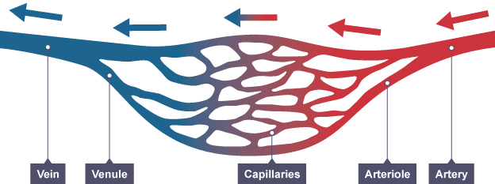
Blood travelling through the capillaries
The heart
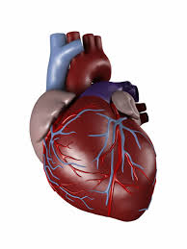
The heart is the most important organ in the circulatory system. This organ is a muscular pump, pushing blood through the body. It beats between 60 and 100 times per minute and during a 70 year lifetime the heart beats about 2.5billion times. The heart changes its rate depending on how much blood the body needs at a given time.
With each heartbeat the heart sends blood throughout our bodies delivering oxygen and nutrients to every cell. After delivering oxygen, the blood becomes deoxygenated and carries carbon dioxide back to the heart. The heart then pumps the deoxygenated blood to the lungs where the blood picks up new oxygen and drops off the carbon dioxide (where it is breathed out). The oxygenated blood then returns back to the heart and the heart pumps it out to the body so the cycle repeats again and again.
Therefore the human circulatory system is a double circulatory system. It has two separate circuits and blood passes through the heart twice:
- the pulmonary circuit is between the heart and lungs
- the systemic circuit is between the heart and the other organs
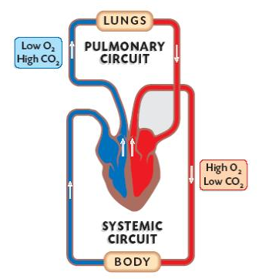Task 1
- Watch the following videos on BBC Bitesize KS2 to develop your understanding: What is the circulatory system? What is your blood? What are blood vessels? https://www.bbc.co.uk/bitesize/topics/zwdr6yc Another good video is: Exploring the Heart-The Circulatory System! https://www.youtube.com/watch?v=-s5iCoCaofc
This next task we normally complete in small groups within class but you should be able to complete this task at home. Children within each group would have been asked to draw a life size body outline by drawing round one person lying on the floor (onto a large piece of paper). If you have an old roll of wall paper you could use that or use chalk on a hard outside surface (although you will need some help), if not draw an outline of the human body onto an A4 sheet. Then use your own knowledge to draw on the following organs: the heart, the lungs and the kidneys. Finally draw on the circulatory system, using a red pen (or chalk) to represent the arteries and blue pen (or chalk) to represent the veins. There are a few things you will need to remember:
- When you look at your drawing the right hand side is actually the left hand side of your actual body.
- Oxygenated blood in the arteries (represented by the red pen or chalk) flow away from the left hand side of your heart and deoxygenated blood in the veins (represented by the blue pen or chalk) flows back to the right hand side of your heart.
- Don’t forget to show the loop between the heart and the lungs.
- Draw the main blood vessels to the heart, lungs, head, legs, feet, toes, hands and kidneys
- Finally remember that veins and arteries create a continuous loop and never have a dead end.

Challenge task:
In most diagrams of the circulatory system the veins and arteries are only represented but we know that the capillaries (smallest blood vessel) link the veins and arteries together. For the challenge you could add in another colour to show this!
Answers: Use Resource 6.2.4 Circulatory System to check your diagram. Have you placed the organs in the correct place? Are your blood vessels shown by a continuous loop? Do your blood vessels travel up to the head and then right down to your feet? Do you need to make any adjustments?
Task 2
Finally complete the ‘Circulatory test’ worksheet to check your understanding.

