Circles Work – Subtraction Fluency Questions
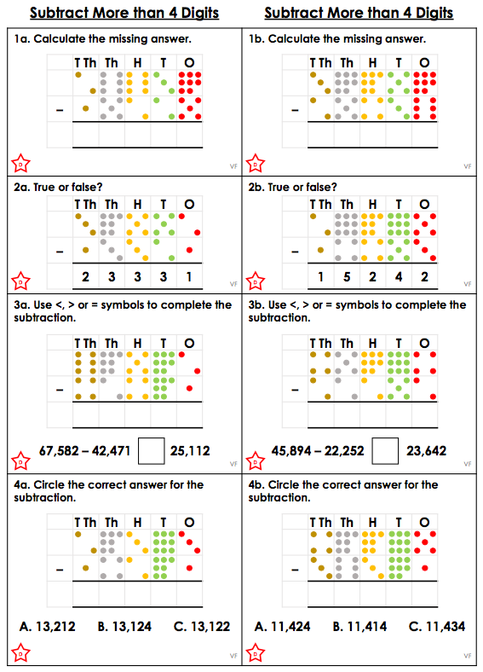
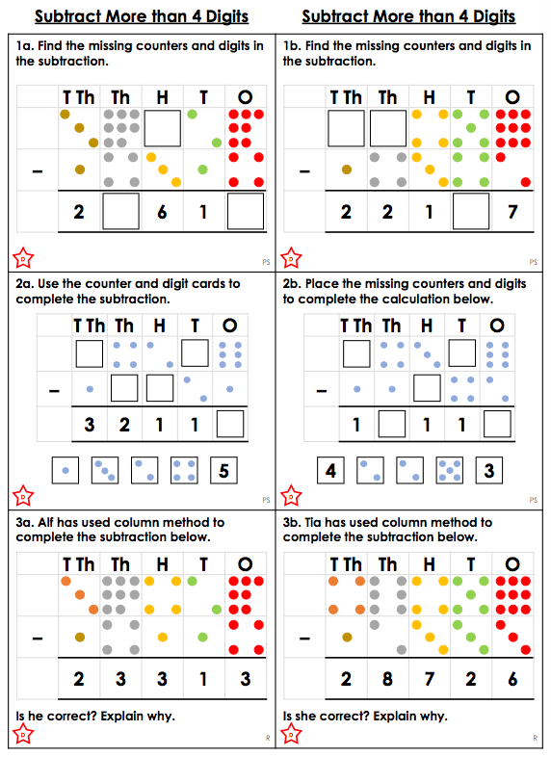
Circles Work – Problem Solving Questions

Circles Work – Answers

Fluency
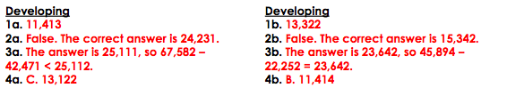

Problem Solving

