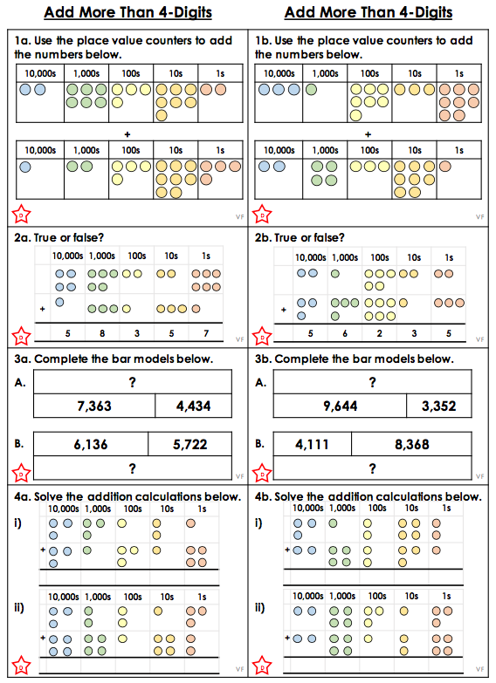
Circles Work – Addition Fluency Questions
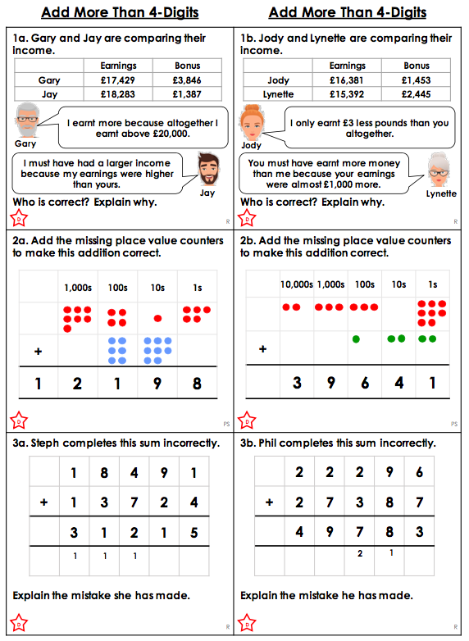
Circles Work – Problem Solving Questions

Circles Work – Answers

Fluency

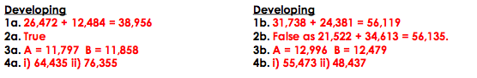

Problem Solving

