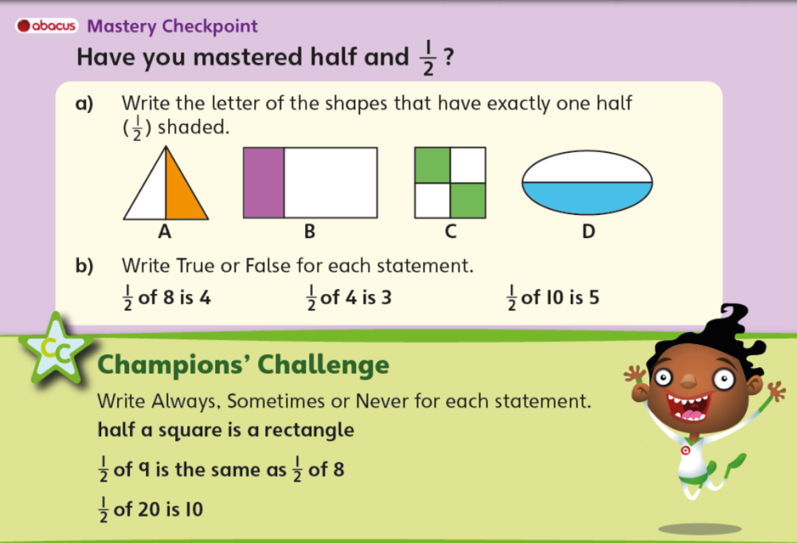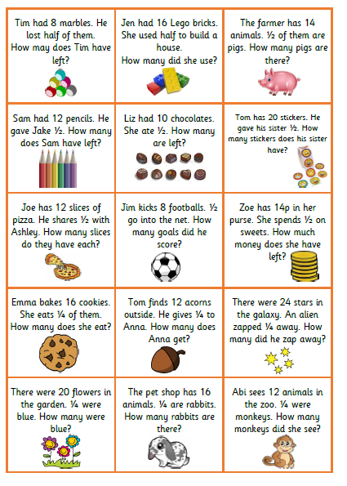

**A challenge!**

**Have a go at solving these problems. Be careful because the last 6 questions involve quarters not halves!**

**A tip to solving a quarter of an amount is to find half and then half again. I.e. ¼ of 8 =**

**½ of 8 = 4 and then ½ of 4 = 2 so ¼ of 8 is 2.**