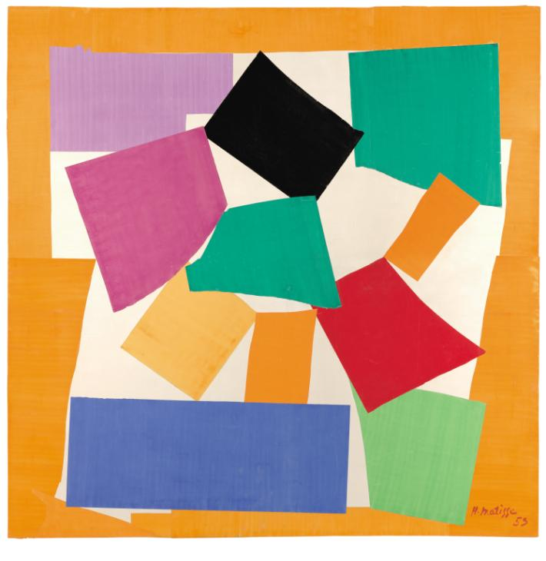
Questions to ask about Henri Matisse’s artwork

- What animal do you think Henri Matisse has created?
- Do you enjoy looking at this piece?
- If so, talk about what is enjoyable about it.
- Give examples, to your helper, about what you like about this piece.
- What kind of materials do you think Henri Matisse has used to make this?
- How does the picture make you feel?

