Art - L.O. To design and create a propaganda poster.
During World War 2 the war was heavily fought with propaganda (spreading ideas), as both sides needed to convince their people that the war was right and that their side would win. Both sides manipulated (influenced/engineered) public opinion (view) to keep up morale (confidence) and to break down enemy morale. Some propaganda posters were simple and clear, some were subtle and some were a little impolite.
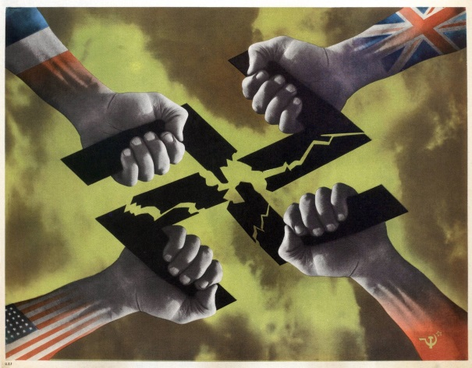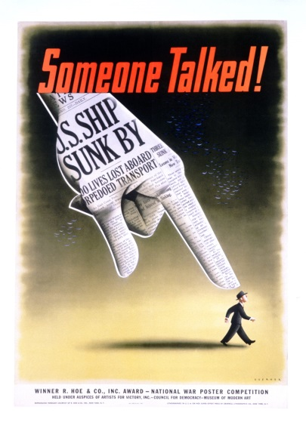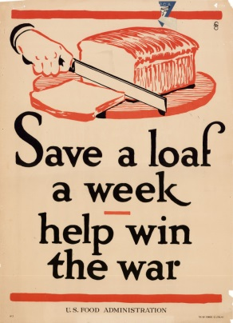
Have a careful look at these different propaganda posters. What do you notice? What symbols have been used? What is the meaning behind each of these propaganda posters?
_______________________________________________________________________________________________________________________________________________________________________________________________________________________________________________________________________________________________________________________________________________________________________________________________________________________________________________________________________
Have another look at these posters. How have they been designed? Do all the posters have text? What do you notice about the style of the text? Are they very detailed or quite simple? What colours have been used in the posters?
______________________________________________________________________________________________________________________________________________________________________________________________________________________________________________________________________________________________________________________________________________________________________________________________________
Now that you have analysed different propaganda posters I would like you to design your own WW2 poster. Think about the message you would like to create, how are you going to manipulate the viewer? Do you want to persuade people that we are winning the war or that we need soldiers to enlist or that we should be turning our gardens into vegetable plots? Consider the text (if you are using any), the images and the colours you would like to use. There are lots of different examples of propaganda posters in books and online (check with an adult first) to help develop your ideas.
First of all I would like you to sketch several different ideas and then develop one design. Work on an A4 or A3 piece of paper. Give your finished piece of work colour by using coloured pens/pencils, paints, pastels or collage materials.
I will look forward to seeing your wonderful piece of work!
S.C.
1. Have I chosen the message that I would like to show in my propaganda poster?
2. Can I use images that have specific meaning (symbolism)?
3. Have I sketched out several possible design ideas?
4. Have I chosen my final design and then sketched it out onto an A4 or A3 piece of paper?
5. Have I used bright, bold, colours?

