Prayer Beads
When people want to feel close to God they pray.
Muslims use prayer beads to help them feel close to Allah. Prayer beads are very precious and special. There are 99 beads and they help Muslims remember the 99 Beautiful Names for God.
Muslims call God ‘Allah’ however in their holy book called the Qur’an, there are lots of other names for God too.
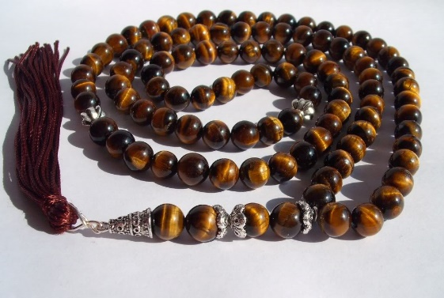

People who follow the Catholic faith also use beads called a ‘Rosary’ when they pray.
Reflection – What do you own that is precious and special to you?
- Draw a picture and write a sentence to explain why it is special to you.
- If you have beads at home can you practise your threading skills.
- How many beads can you thread onto your string?

Here is a Mosque. This is a special place where Muslims go to pray to God.
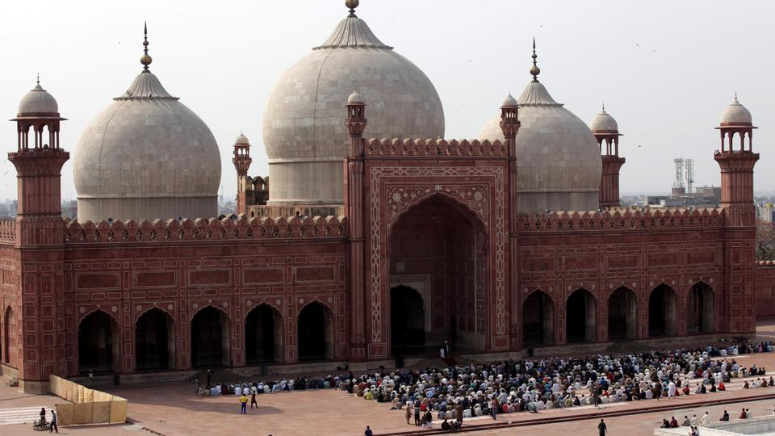
- Build your own Mosque using construction toys or recycling materials.
- Draw a picture of a Mosque.

