**LO: To find 1 more than any number**

**Number 1 more than**

95





109



89



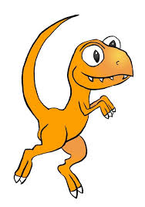

129



145



73

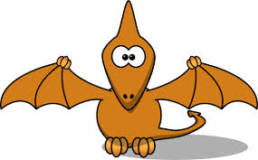



99

**Greater depth**

**Extension**:

Children gave their answers for 1 more. Which child has the correct answer? Colour in their jumper if you think their answer is correct.





6

12

10

11

11 is one more than

**Number**



12

20

22

21

21 is one more than



17

71

15

16

16 is one more than



13

9

15

14

14 is one more than