**LO: To find 1 less than any number up to 20 and above**

**Number 1 less than**

85





99



139



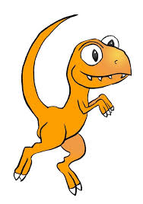

108



123



152

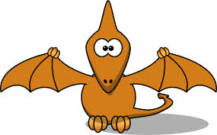



140

**Greater depth**

**Extension**:

Children gave their answers for 1 less. Which child has the correct answer? Colour in their jumper if you think their answer is correct.





6

12

10

11

11 is one less than

**Number**



12

20

22

21

21 is one less than



17

71

15

16

16 is one less than



13

9

15

14

14 is one less than